How to create the script with "Inno setup"...only the screens where the proposed data is modified are shown.
Warning! The file created using the wizard has been modified over time!!!! Please refer to the .iss file in this folder!!!
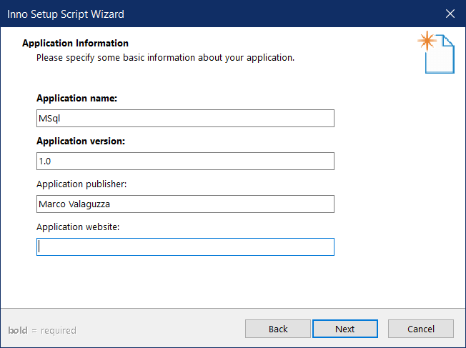

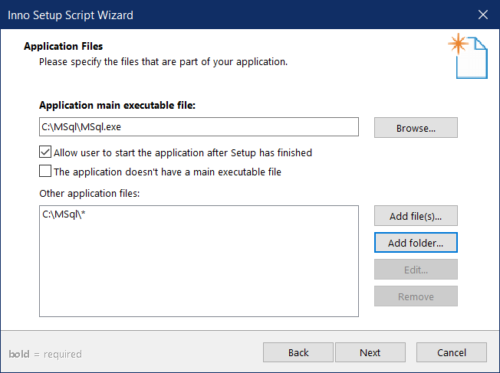

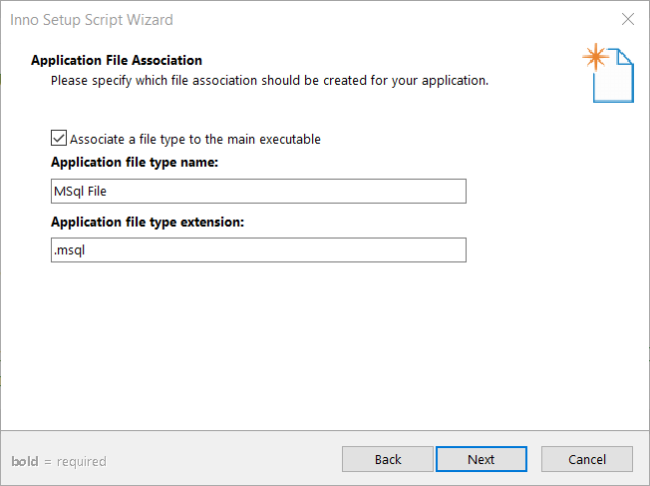

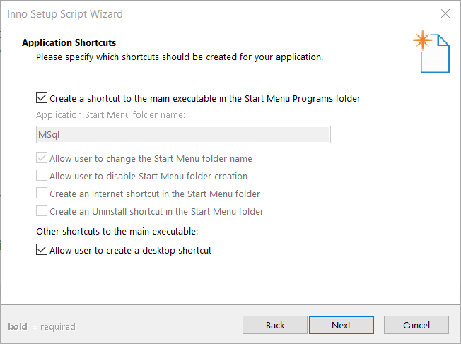

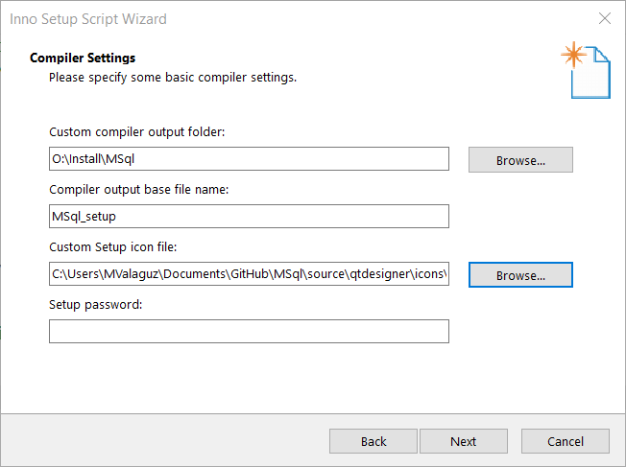

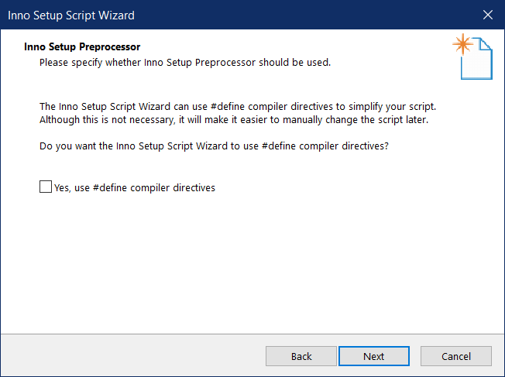

Once the script has been generated, insert the instructions to indicate that a presentation page with the logo is to be created (this is in the [Setup] section)….note that the image is in bmp format!

; Activate splash image to program startup
DisableWelcomePage=no
WizardImageFile=C:\Users\mvalaguz\Documents\GitHub\MSql\source\qtdesigner\icons\MSql.bmp

